**CASE TOOLS LABORATORY**

**ISA-2**

**Topic- Mantis**

**Members:**

**Ankit -2105024**

**Shreyash -2105016**

**What is Mantis Bug Tracker ?**

Mantis Bug Tracker is a free and open source,cross platform, web-based bug

tracking system. The most common use of MantisBT is to track software defects.

MantisBT is often configured by users to serve as a more generic issue tracking

system and project management tool.The name of the project is typically abbreviated

to either MantisBT or just Mantis.It is written in PHP language and is available in 49

languages.It was initially released in 2000(about 22 years ago).

**Why do we need a Bug Tracking System?**

To manage the issues logged during software development life cycle proper

managing systems are required. A bug tracking facilitates in managing bugs so that

proper track record of the bugs could be maintained, and be accessible to the team

members working towards the development of the project.

**Requirements for MantisBT**

MantisBT requires a configured web server, the PHP programming language

interpreter and a relational database management system supported by MantisBT.

The stable branch of MantisBT requires PHP. Several PHP extensions are required

to enable specific functionality or for performance reasons; the extension for the

RDBMS being used (i.e. mysql) is mandatory.

**Technical Design**

**Development languages**

MantisBT is mainly written in PHP and uses SQL to interface with databases. The

web-based user interface of MantisBT is written using HTML which is styled and

presented using CSS. Development tools and build scripts are written predominantly

in Python with some Shell script and PHP.

**Database storage**

MantisBT supports MySQL. Support for other databases ( PostgreSQL, Microsoft

SQL, Oracle ) is known to be problematic. MantisBT maintains a database upgrade

path between versions by modifying the database schema incrementally. During the

installation of MantisBT, database schema modifications are replayed all the way

back from early versions of MantisBT to reach the latest state.

**Salient Features of Mantis:**

**Plug-ins**

The plug-in system allows extension of MantisBT through both officially maintained

and third party plug-ins. There are over 50 plug-ins available on the

MantisBT-plugins organization on GitHub. A third party plug-in system created by

Vincent Debout was available to users along with a variety of different plug-ins.This

system was not officially supported by the MantisBT project and is incompatible with

MantisBT.

**Mobile Support:**

Mantis supports iPhone, Android and Windows Phone Platforms.

**Notifications**

MantisBT supports the sending of e-mail notifications upon changes being made to

issues in the system. Users have the ability to specify the type of e-mails they

receive and set filters to define the minimum severity of issues. Users also have the

ability to explicitly subscribe to issues that affect them.

MantisBT has integration with Twitter via a plugin, to allow a notification to be

tweeted when an issue is resolved.Via MantisBT's event-driven plug-in system, it is

possible to extend the built in notification support to run advanced scripts that

perform additional notification actions (such as sending SMS messages).

**Revision control system integration**

MantisBT allowed for limited integration with the CVS revision control system. The

initial release of the SourceIntegration plugin supported GitHub, GitWeb,

SourceForge . Upon committing change sets to a source code repository,

post-commit hooks within Git can be configured to automatically notify MantisBT that

changes have been made to the repository.

GitHub is also capable of remotely notifying a MantisBT installation of changes to a

source code repository.

**Features**

MantisBT also has support for

● Full text search

● Roadmaps

● Changelogs

● News

● Project Management & TimeTracking

**Disadvantages of Mantis :**

● The interface. As mentioned above, it is very convenient and easy, but at the

same time it is quite gloomy. Apparently the developers of Mantis are very

harsh and unpretentious, but everybody isn’t like that, so the system design is

more likely a disadvantage.

● The program slowly works with a large amount of information, so it is

unsuitable for long-term projects and processing of much data.

● Those, who like illustrations, will be upset by the ability to attach only one

screenshot. One can add new screenshots after saving, but only one at a

time.

**Advantages of Mantis:**

● It is easy to use and very simple. It has its own inbuilt bug tracking feature

which helps us for effective reports for the specific issues.

● It's very user friendly and good value for money.

● Very flexible, great software, exactly what you needed for your software

development for Magento modules.

● Very simple, user friendly and most of the bug reporting and monitoring

parameters are pre-configured. Integration with 3rd party software

management tools is possible.

**Why to choose mantis BT ?**

As it provides a delicate balance between simplicity and power. Users are able to get

started in minutes and start managing their projects while collaborating with their

teammates and clients effectively. Once you start using it, you will never go back!

**Conclusion**

Bug tracking software helps to manage the bug effectively, and efficiently. Ultimately,

reducing time, and efforts in managing bug history. With proper management of

bugs, we can improve the quality of the work process and can avoid any loopholes in

the process for testing, and development. With proper tracking, one can expect

proper utilization of the resources.

**How to Install and Use Mantis Bug Tracker**

**1. Download the XAMPP and Mantis file on your computer.**

XAMPP Download Link: - Download XAMPP (apachefriends.org)

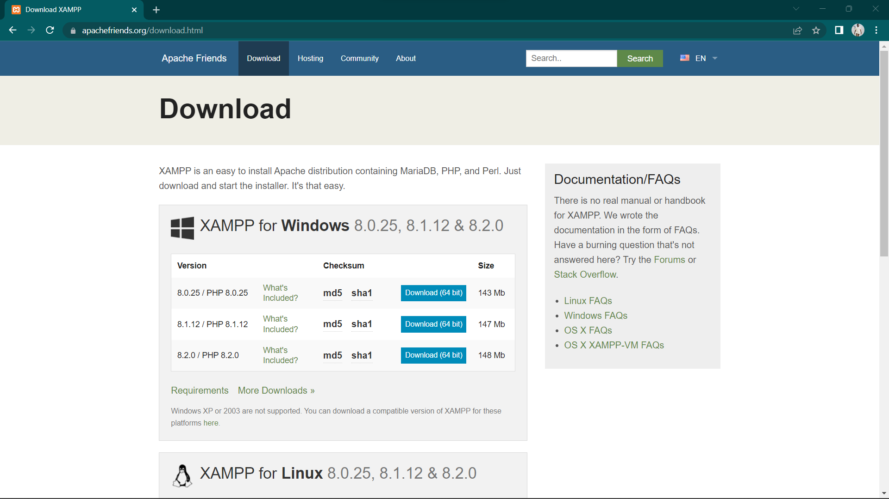

**2. After download run that XAMPP.exe, It will pop up this**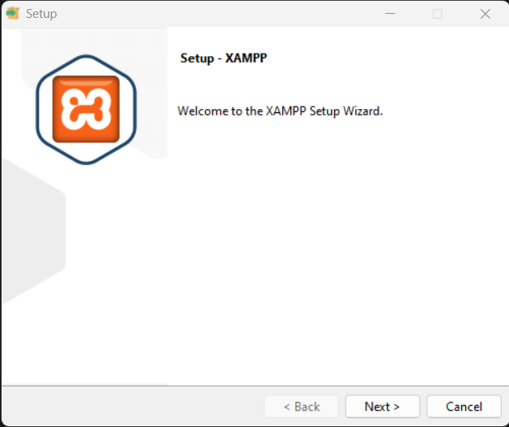

**3. After downloading run the XAMPP.exe, It will pop up the Installing window Click**

**next.**

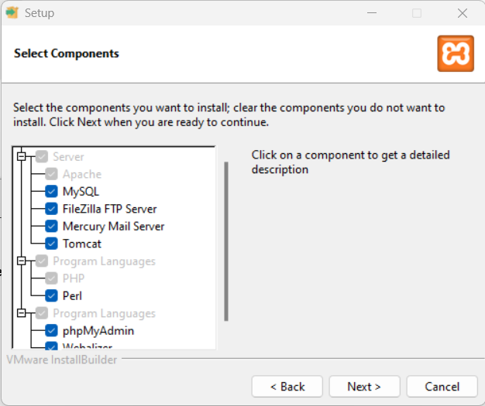

**4. Click next**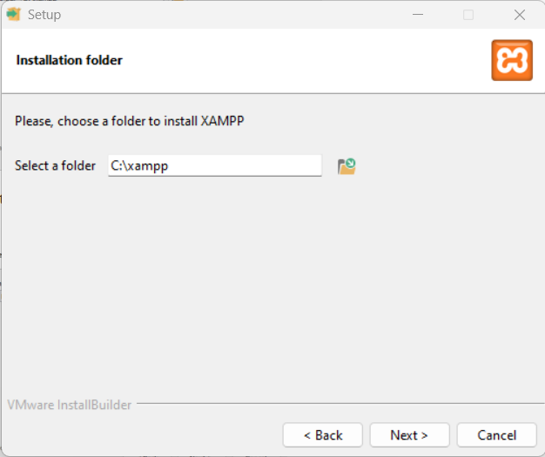

**5. Set the XAMPP folder path where you want.**

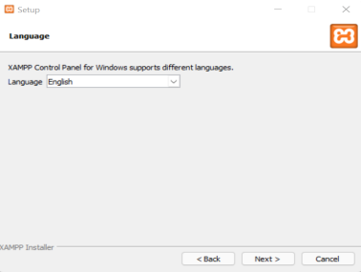

**6.Select your desired Language.**

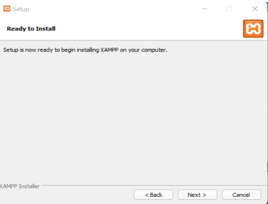

**7.Click next.**

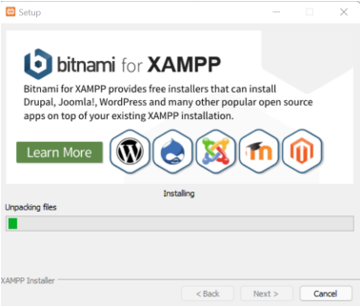

**8.It will start Unpacking and installing.**

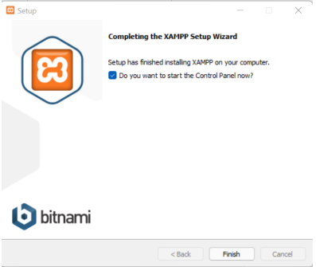

**9.After its done installing click finish.**

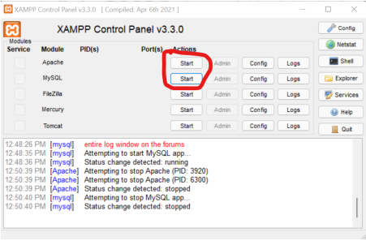

**10 - Click the Start button for Apache and MySQL, required for Mantis as shown in the**

**above screenshot.**

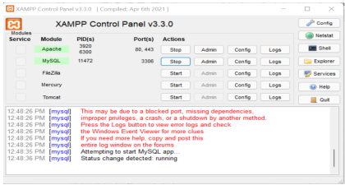

**11 − To verify whether all the prerequisites such as Apache, PHP, and MySQL is**

**installed properly, navigate to any of the browser, type http://localhost and press Enter.**

**It will display the dashboard of XAMPP. Click phpMyAdmin at the right top corner as**

**shown in the following screenshot.**

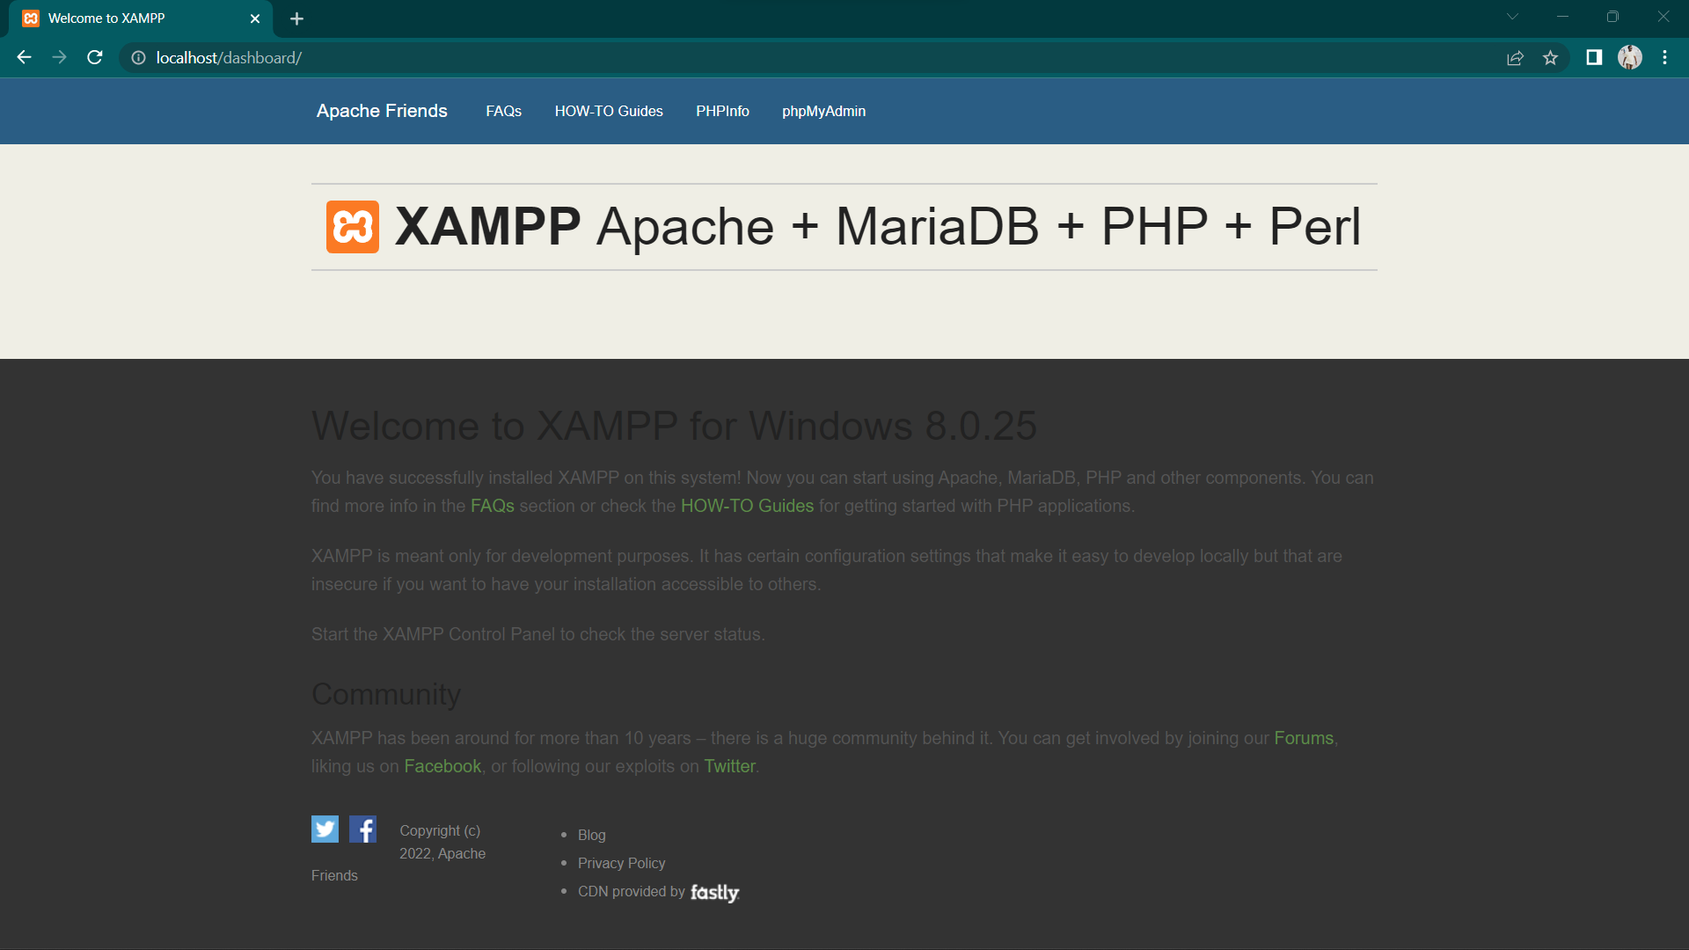

**The next screenshot will display General Settings, Application Settings, Details of**

**Database, Web Server, and phpMyAdmin.**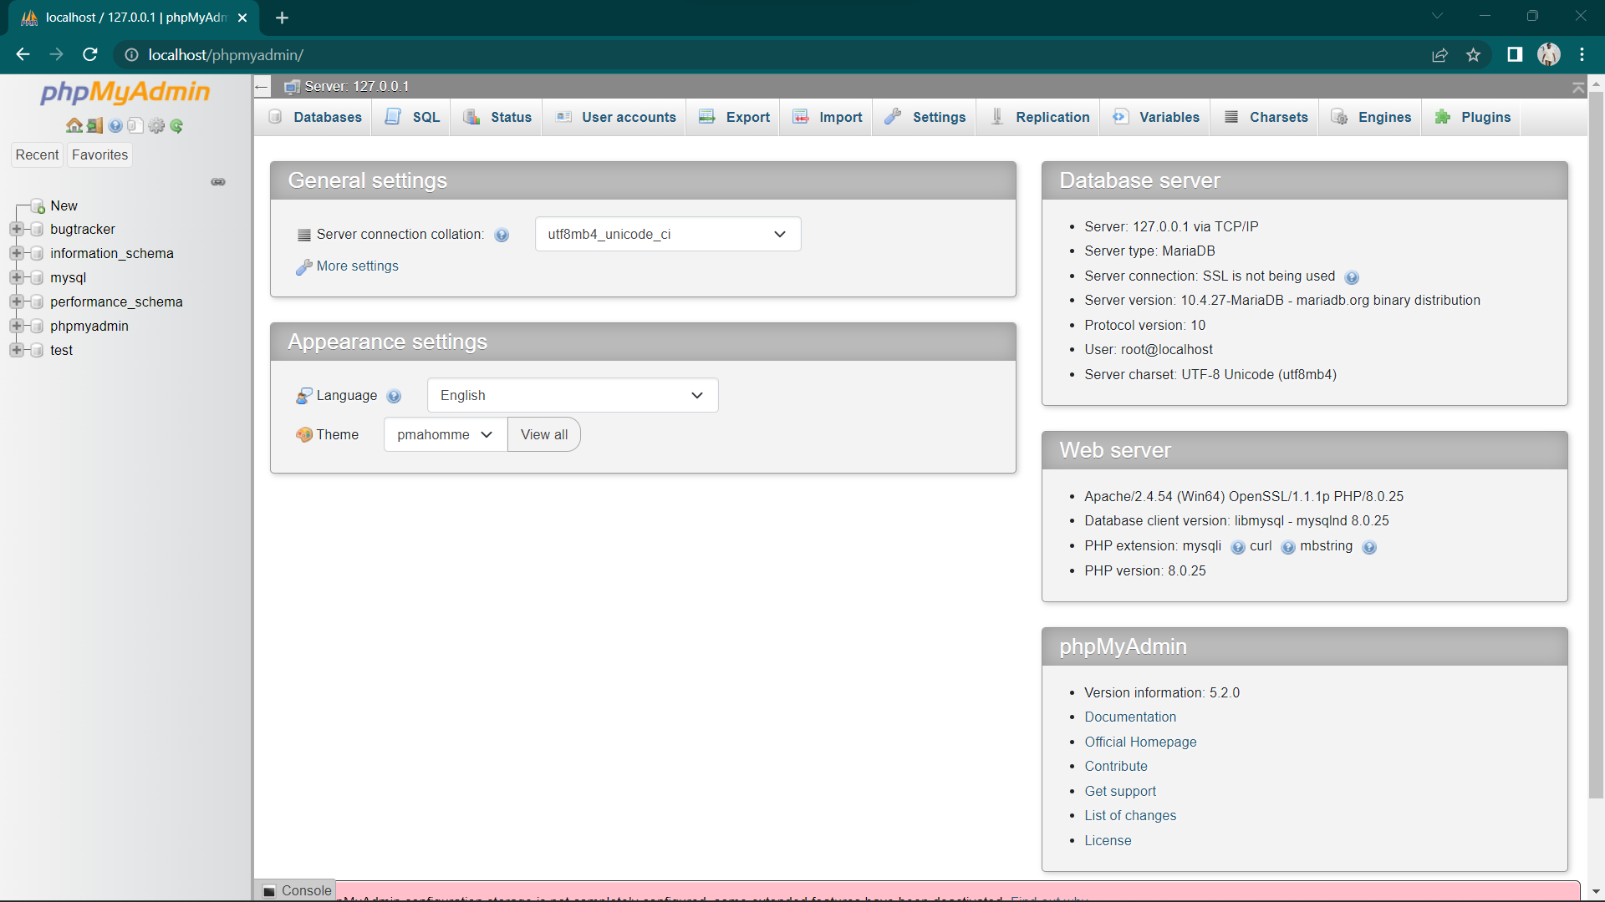

**If the installation is not proper, this page won’t be displayed. Till this point, all the**

**prerequisites are successfully installed in the system.**

**Install and launch mantis**

**1 − Mantis File Download Link:-** [**https://sourceforge.net/projects/mantisbt/files/mantis-stable/2.25.3/**](https://sourceforge.net/projects/mantisbt/files/mantis-stable/2.25.3/)

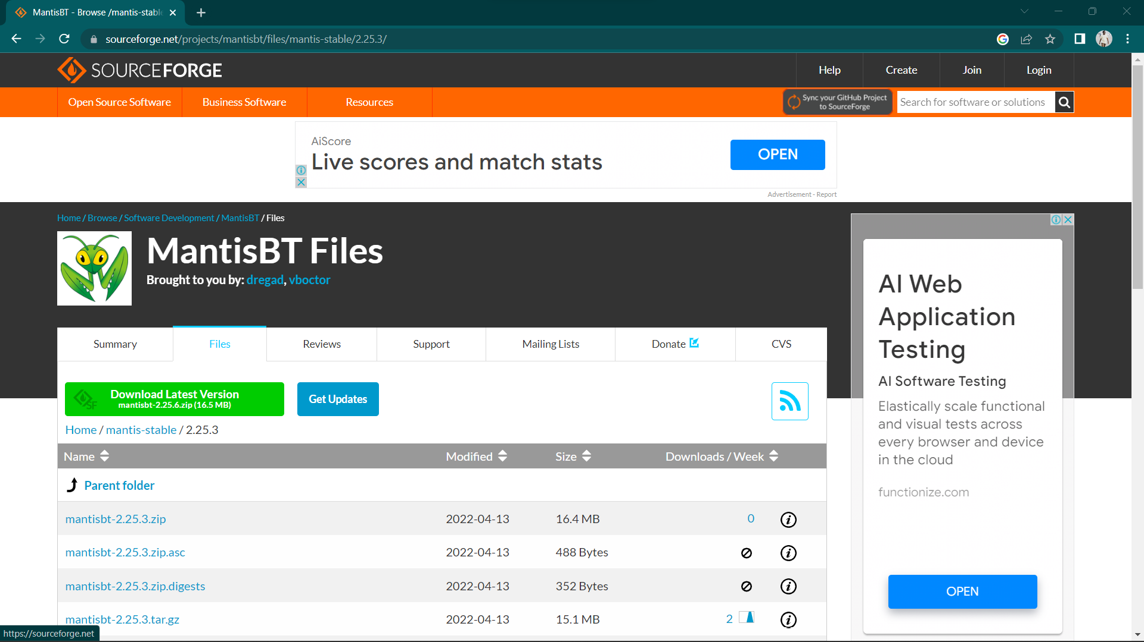

**2. Go to the XAMPP folder where it is installed and navigate to the htdocs folder. Unzip**

**the downloaded mantis and place it as shown in the following screenshot.**

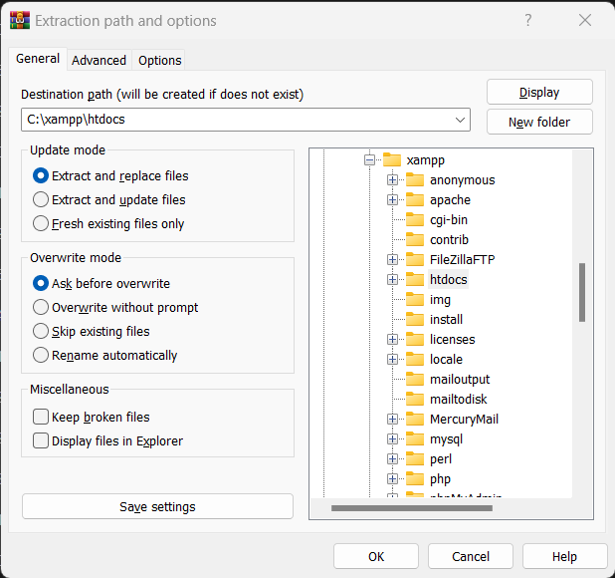

**3 − Rename the folder name mantis** **2.25.6 as mantis for better URL.**

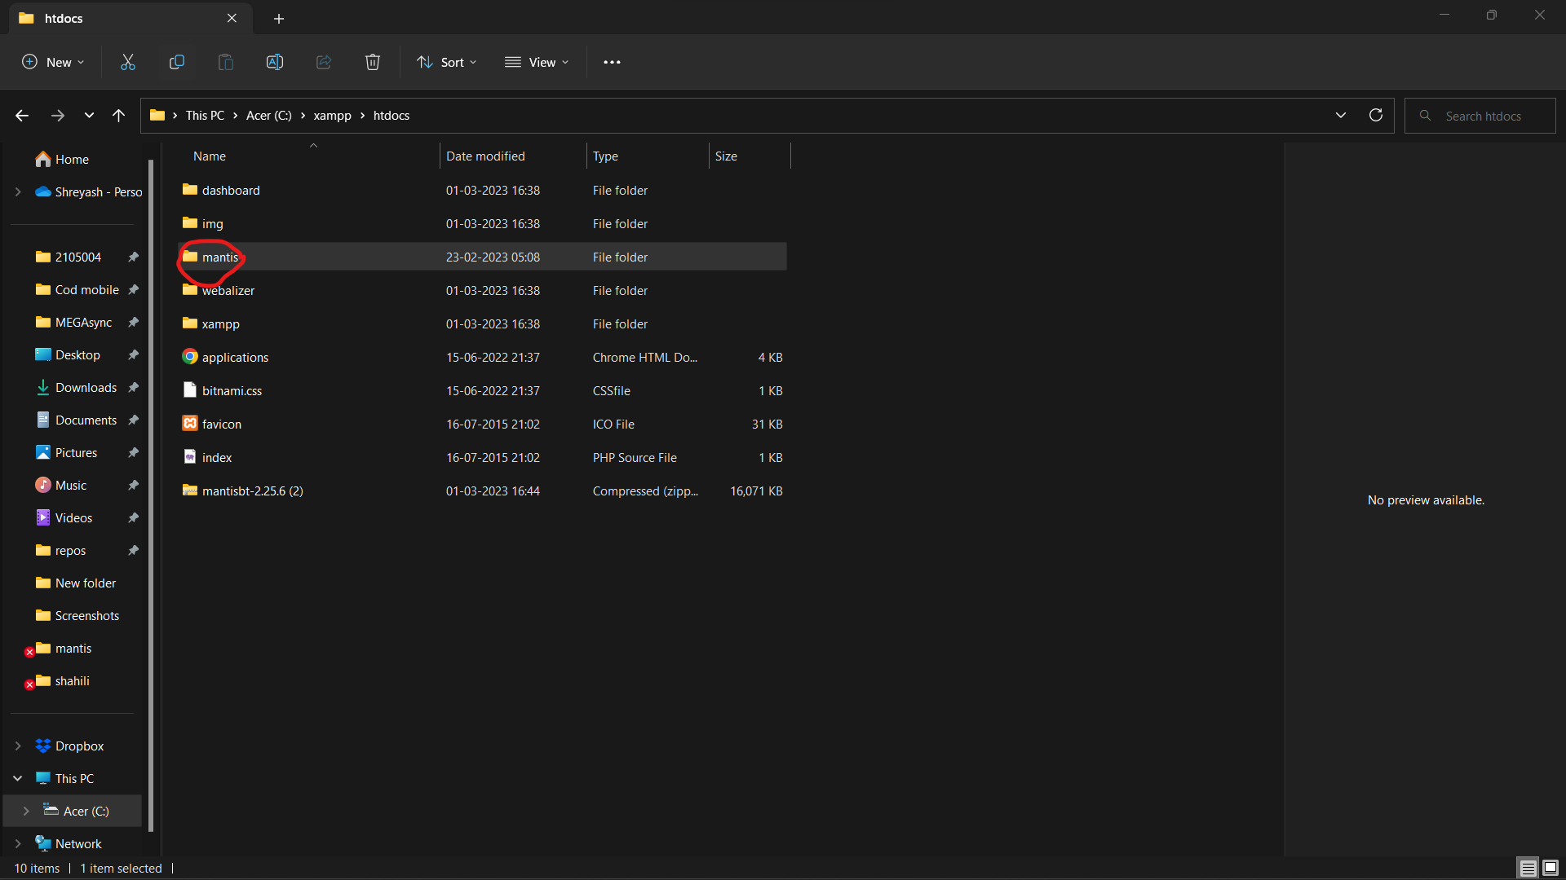

**4− Now open a browser and type http://localhost/mantis in the navigation bar and press enter. It will display the Pre-Installation page as shown in the following screenshot.**

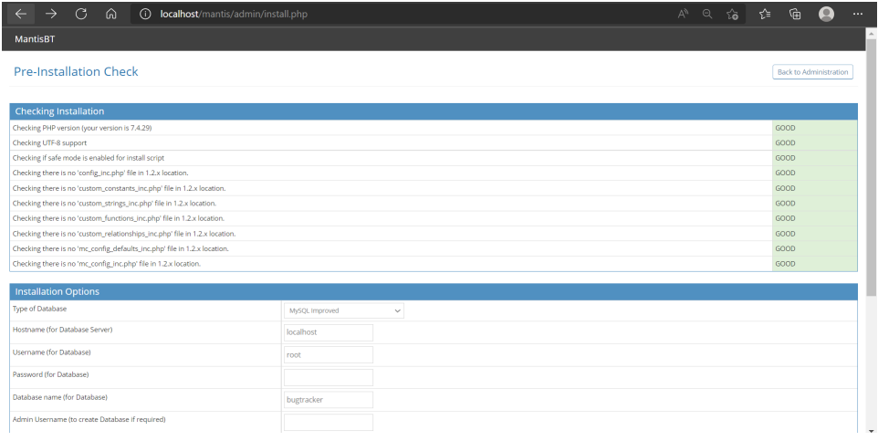

**5 − Go to the Installation section and make changes, if required. Then, click the**

**Install/Upgrade Database button.**

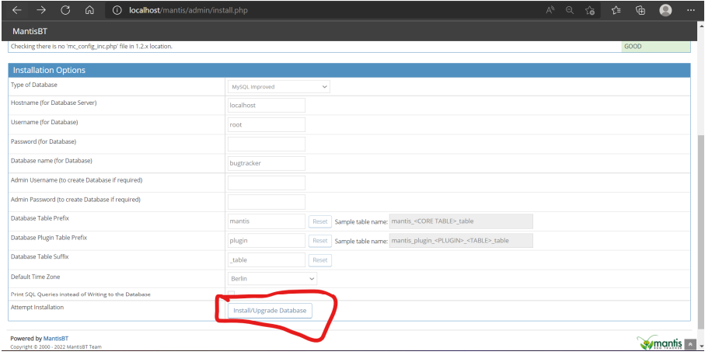

**Once installation is complete, it will display the Check installation page and will be**

**marked as Good, i.e., Mantis is installed properly.**

**6− To launch mantis, use the URL http://localhost/mantis and click mantis-2.25.6. It will display the Login page of Mantis as shown in the following screenshot.**

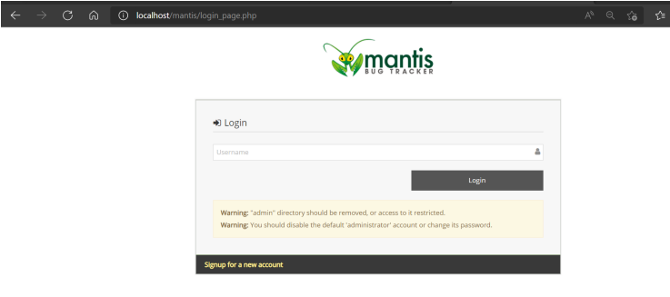

**7 − Provide the username as “Administrator” and click Login. It will ask to enter the password. Use “root” as password and click Login.**

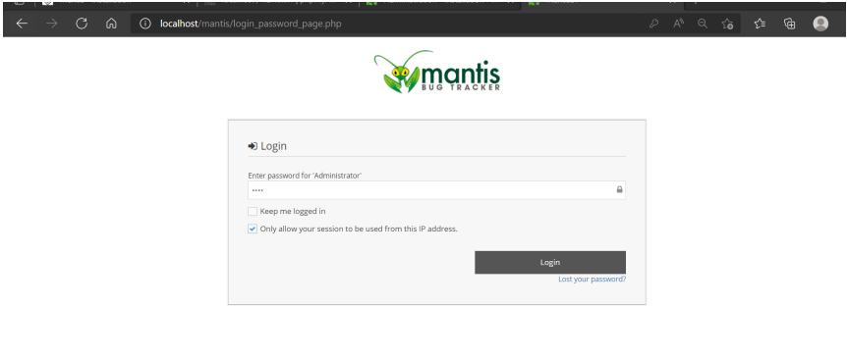

**After successful Login, it will display the Dashboard of Mantis.**

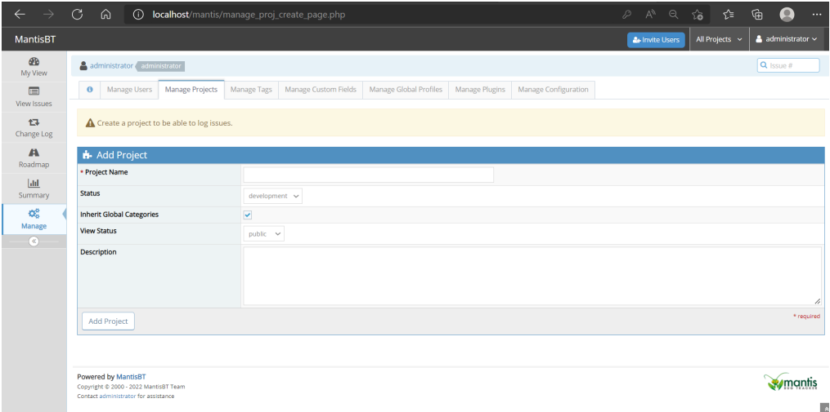

**Project Management**

**How to create Project**

**1 − Go to the “Manage” section present at the left menu bar.**

**2 − Click the “Manage Projects” tab.**

**3 − To create a new project, click the Create New Project button. To edit an existing**

**project, click the Project Name. Here, “My Project” is the existing default project.**

**The following screenshot shows how to create a new project.**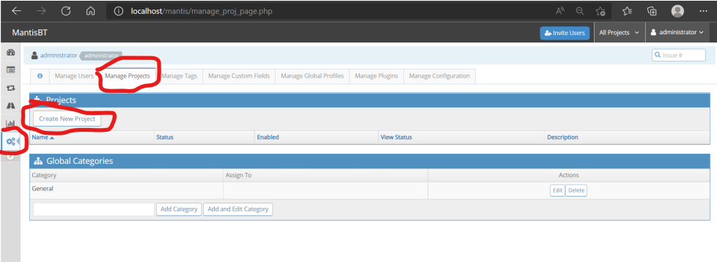

**5 − After clicking Create Project / Project Name, the Create Project form opens.**

**6 − Enter the following fields before creation −**

**● Name − Enter the project name.**

**● Description − A brief description or summary of the project.**

**● Status − The maturity or development status of the project. This is an informational**

**field and doesn’t affect Mantis.**

**● View Status − It determines who can access the project, and whether the project can**

**be viewed by all logged-in users in the case of public projects. Private projects are**

**only visible to users assigned to the project or to administrators.**

**7 − Now, click the Add Project button.**

**The following screenshot shows the fields to enter/edit to add/update a new project.**

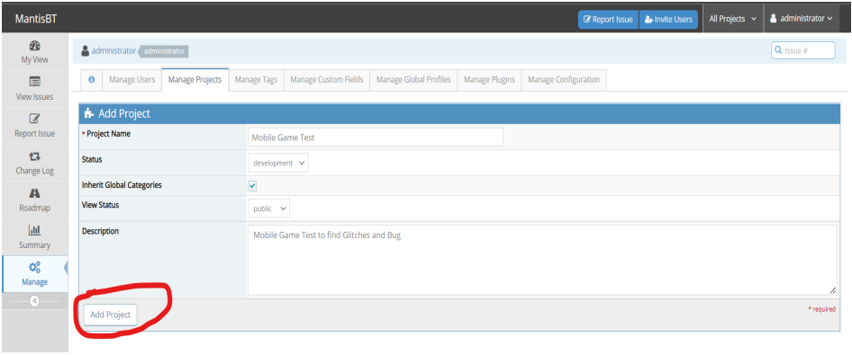

**On successful creation of a project, the user can see a new entry in the project section as shown in the following screenshot.**

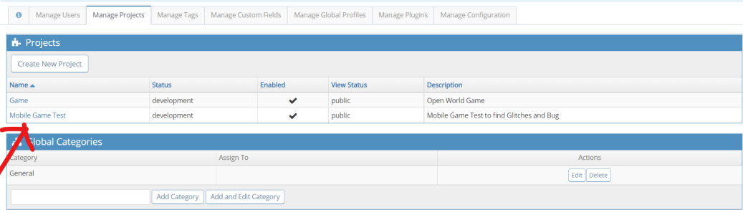

**8.Double Click on Project.**

**After that project form will be open there you can update or delete the current project.**

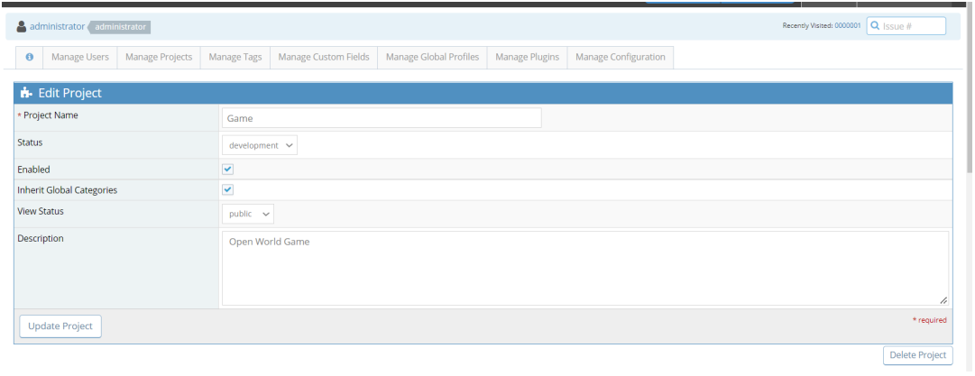

**From here you can see all your projects.**

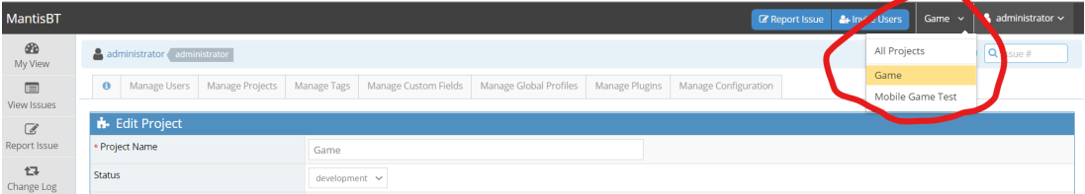

**Create a Category**

**Step 1 − Go to Manage → Manage Projects tab.**

**Step 2 − Enter the Category name in the text box and click Add Category.**

**The following screenshot shows how to add a Global Category.**

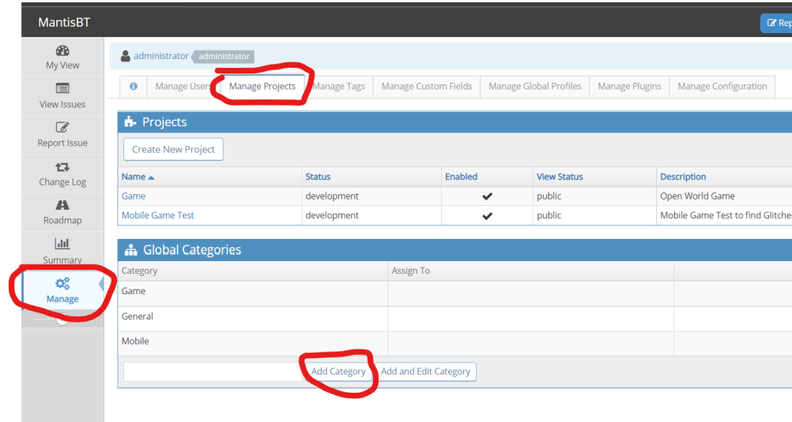

**Configure Categories**

**Categories can be configured to a default assignee.**

**All issues logged under this category will automatically be assigned to a team member.**

**Step 1 − To configure the category, go to Manage → Manage Projects → Global Categories**

**Step 2 − Click Edit to configure a specific category as shown in the previous screenshot.**

**Step 3 − In the Edit Project Category, select Assigned to from the dropdown list.**

**Step 4 − Click Update Category.**

**Here, the user can edit the category name as well.**

**The following screenshot shows how to configure a category.**

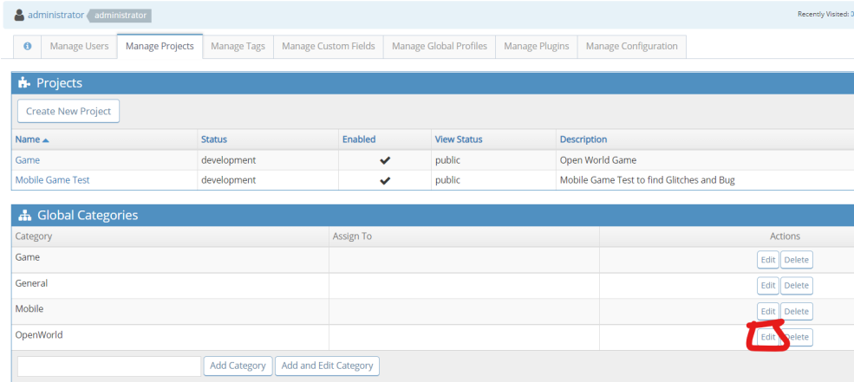

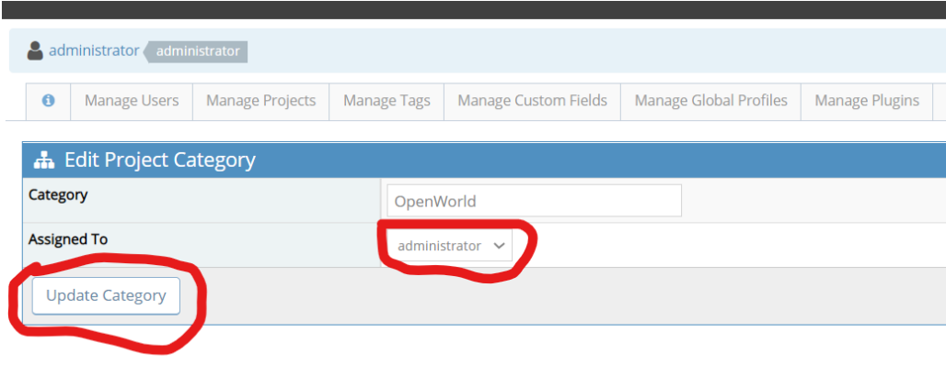

**Delete a CategoryStep 1 − To delete a category, go to Manage → Manage Projects.**

**Step 2 − Click a specific category to delete. Then, click the Delete button from the actions column as shown in the following screenshot.**

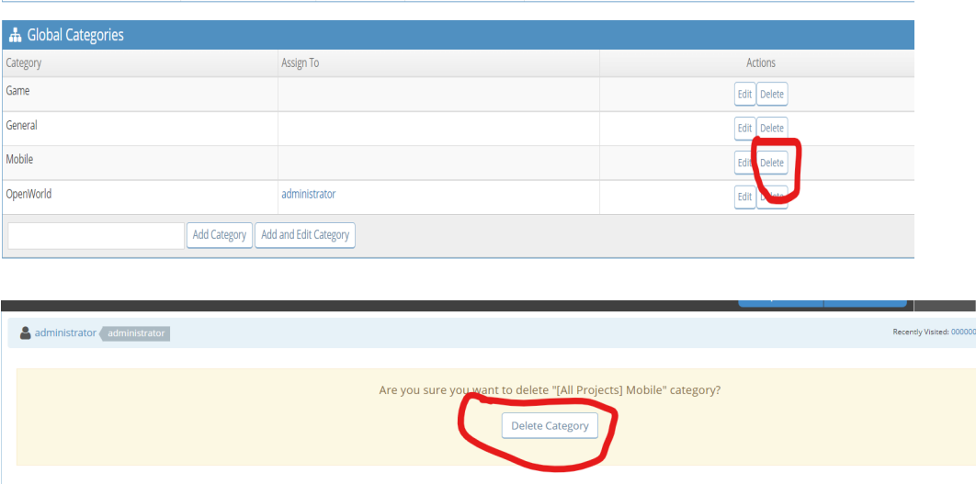

**Report an issue1 − Click the Report Issue link present at the top beside the project.**

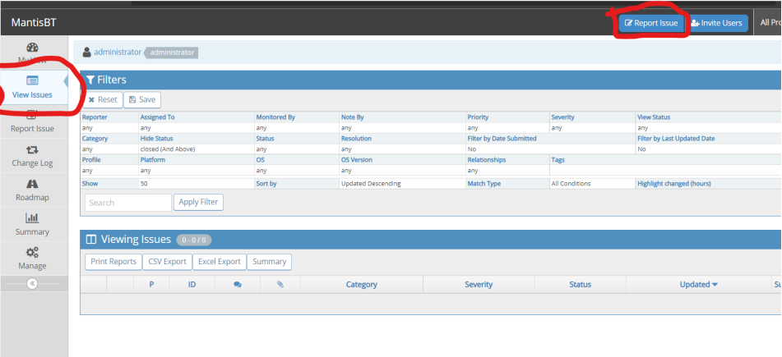

**2. Select The project**

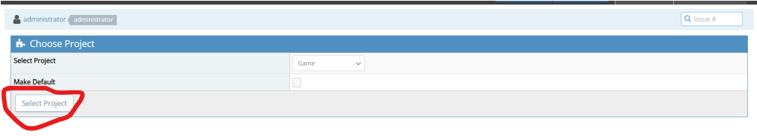

**3. Fill the report form as show below screenshot**

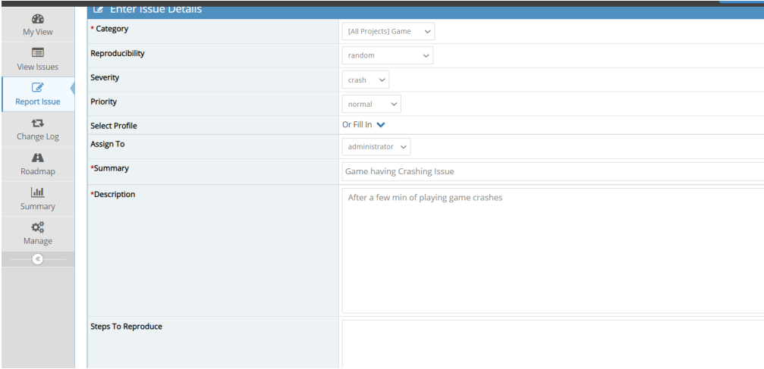

**4. Then click on Submit Issue.**

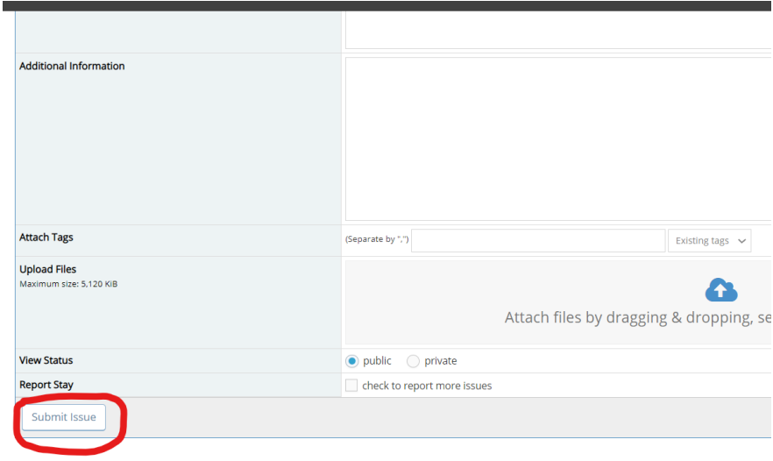

**After successful creation, the user navigates to the View Issue page, where the new reported issue can be seen.**

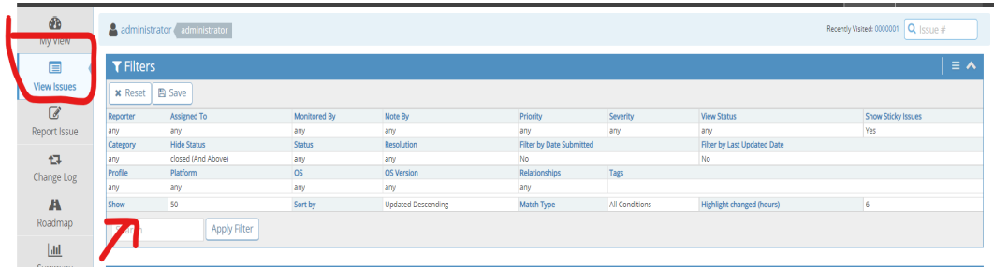

**Edit Issue**

**1. GO to View Issue and then click on report id as shown below screenshot.**

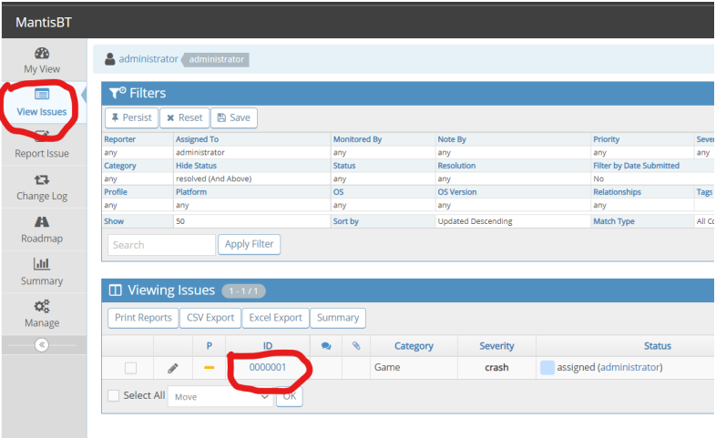

**After that, your report page will open, and click on the edit.**

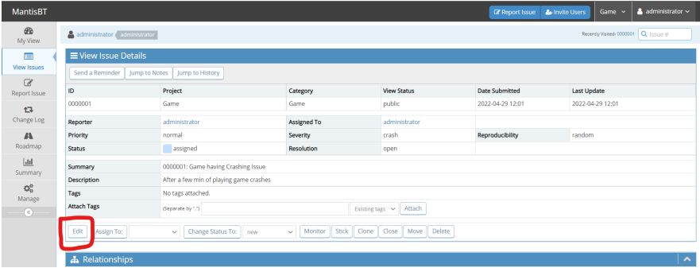

**Edit your report**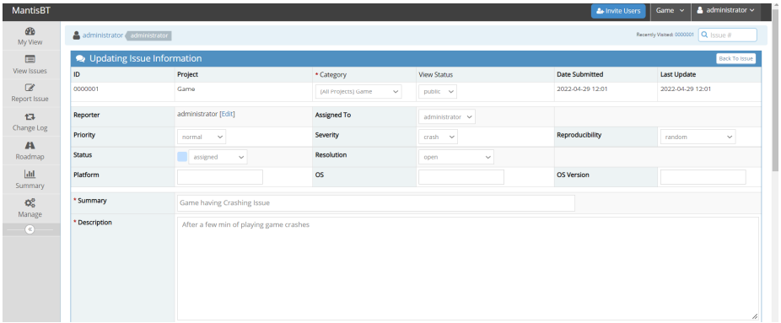

**After entering new details click on Update information. Your report information will be updated.**

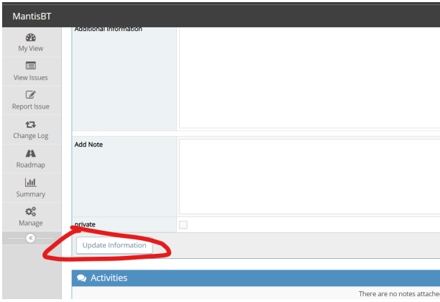

**Clone issue**

**1. GO to View Issue and then click on report id as shown below screenshot.**

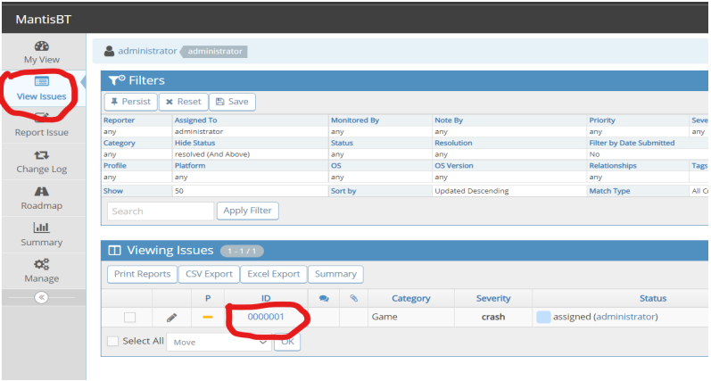

**2. Click on the clone.**

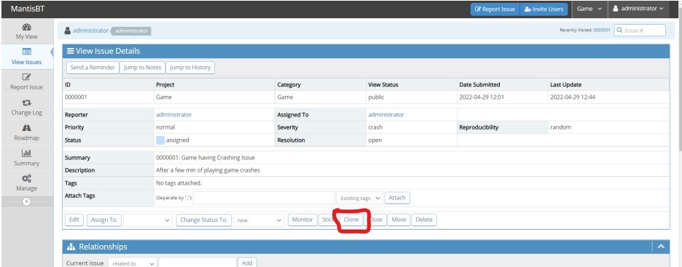

**3. Click on Submit Issue.**

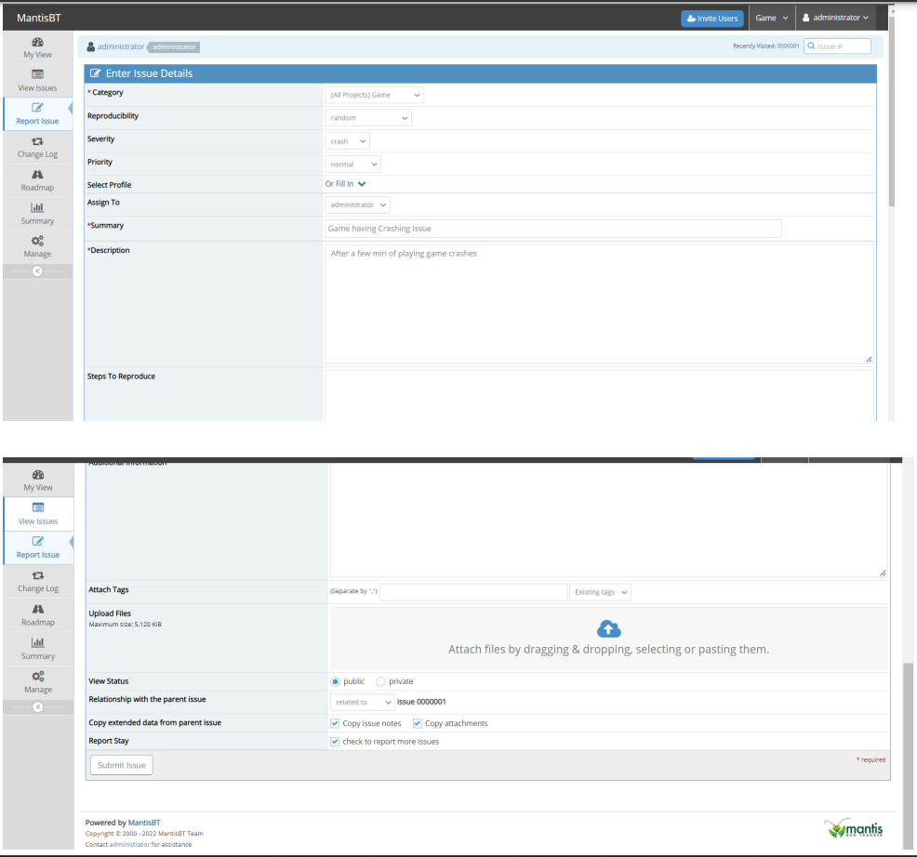

**4. Go to view the issue and there you can see a copy of the original issue.**

